ASSIGNMENT-1

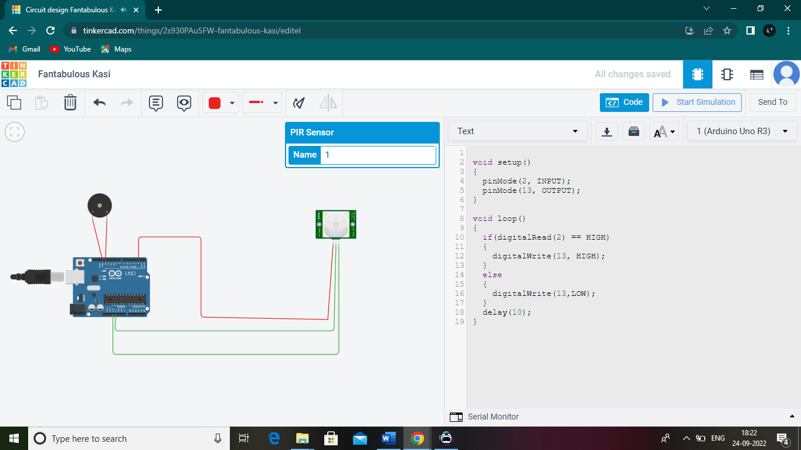

float temp;

void setup()

{

pinMode(6, INPUT);

pinMode(12, OUTPUT);

Serial.begin(9600);

}

void loop()

{

if(digitalRead(6) == HIGH)

{

tone(12,523,1000);

Serial.println("Unknown detected");

}

else

{

noTone(12);

}

temp=analogRead(A1);

temp=temp\*0.48828125;

if(temp>=110.84)

{

tone(12,100,2000);

Serial.println("Above 60 c Temperature...");

}

else

{

noTone(12)

}

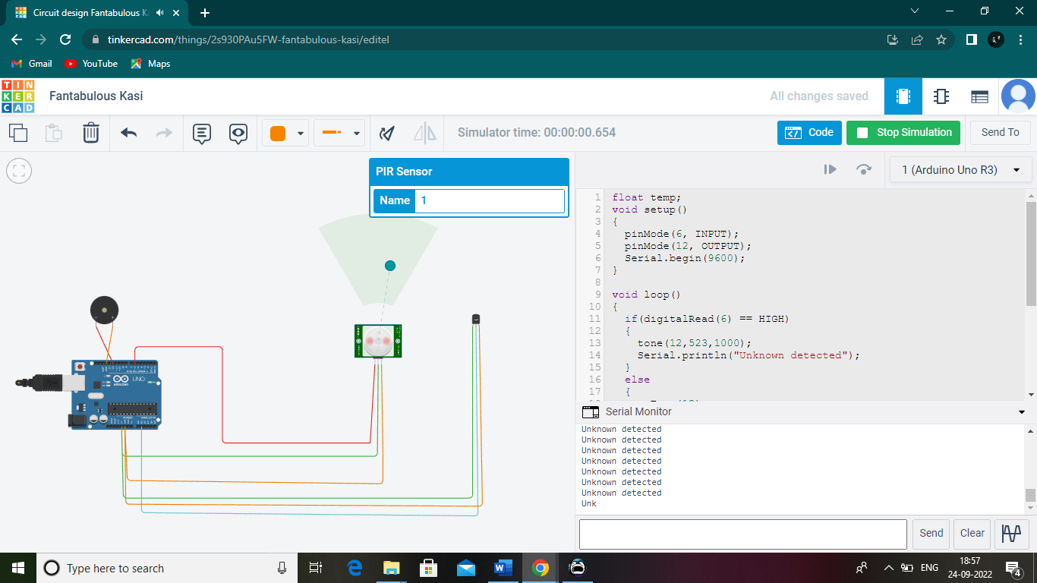

float temp;

void setup()

{

pinMode(6, INPUT);

pinMode(12, OUTPUT);

Serial.begin(9600);

}

void loop()

{

if(digitalRead(6) == HIGH)

{

tone(12,523,1000);

Serial.println("Unknown detected");

}

else

{

noTone(12);

}

temp=analogRead(A1);

temp=temp\*0.48828125;

if(temp>=110.84)

{

tone(12,100,2000);

Serial.println("Above 60 c Temperature...");

}

else

{

noTone(12);

}

}

